# Creating Helpful Content

by Dr. Marie Haynes  
Published June 21, 2023

Welcome to my guide on Google's Helpful Content System. This workbook simplifies Google's complex system that is designed to connect users with the most relevant and helpful content. By exploring how the helpful content system operates, you as a content creator will gain insights on how to effectively optimize your work so that Google’s automated systems are more likely to consider it helpful.

| **You can make your own copy of this workbook by going to File → Make a Copy** |
| --- |

We’ll start by learning about how the helpful content system works. It’s an AI system that predicts whether content is likely to be helpful. If much of your content is not the best option to show searchers, you may find yourself dealing with a suppression at the hands of an unhelpful content classification.

Fortunately, Google has given us a tremendous amount of information on what it is their algorithms seek to reward. It is possible to recover. However, for many sites, improving will be difficult.

We’ll thoroughly study parts of Google’s Search Quality Evaluator Guidelines and also Google’s documentation on creating helpful content.

You will likely want to have these two documents open on your computer as you work through this book:

* [Google’s Search Quality Evaluator Guidelines](https://static.googleusercontent.com/media/guidelines.raterhub.com/en//searchqualityevaluatorguidelines.pdf) (The version we are on right now is the December 15, 2022 version.)
* Google’s Documentation on [creating helpful, reliable, people-first content](https://developers.google.com/search/docs/fundamentals/creating-helpful-content)

**In this workbook**

3

Understanding the helpful content system 4

Can sites recover from a helpful content update classification? 8

How to know if you have been impacted by the helpful content system 10

How to improve content quality 12

Understanding user intent 13

Removing content 19

Removing or moving sections of content 21

You will have difficult decisions 23

De-wordifying your pages 25

Page experience 30

Improving helpfulness by adding content / improving E-E-A-T 32

Popularity 34

Using the knowledge graph to improve E-E-A-T signals 43

Freshness 48

Products 48

Product review criteria 49

**Needs Met** **51**

Which pages to analyze? 51

Understanding Intent & Providing the best page experience 52

**The helpful content criteria for page quality** **55**

Content Quality 55

Expertise 60

Page Experience 62

People first content 65

Final words 69

How to reach Marie 69

### Homework

It’s tempting to just read through this guide without doing the homework. You can do that and you’ll still get value from it, but I’d really encourage you to do the work. Writing down things as you understand them will help you better grasp the concepts and remember what’s important.

We’ll work through a bunch of homework, and then we’ll get into thoroughly analyzing your content and finding ways to improve it.

Let’s get started now…the first homework is to read this article I published that explains more about Google’s machine learning signals. We’ll get into more details about this later, but for now, it will help you understand more about what we are trying to accomplish with this workbook.

[Google’s Helpful Content & Other AI Systems May Be Impacting Your Site’s Visibility](https://www.mariehaynes.com/google-ai-systems/)

## Understanding the helpful content system

It is important for us to understand how the helpful content system works.

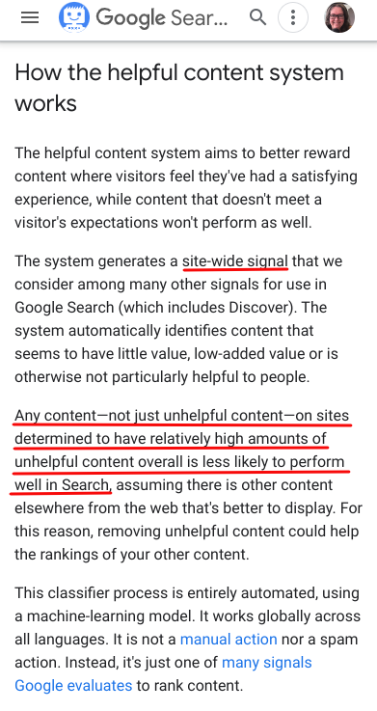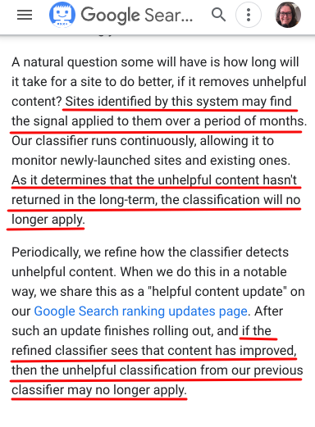

Read Google’s documentation on the [helpful content system](https://developers.google.com/search/updates/helpful-content-update) and answer the following questions.

1. In the first paragraph, what does the helpful content system generate? Why?

2. What does this [document](https://services.google.com/fh/files/misc/hsw-sqrg.pdf) say about “signals”. I’d encourage you to write a paragraph to describe Google’s use of signals in their algorithms.

3. Going back to the helpful content documentation, is the signal applied to an entire site or just to certain pages that are less helpful? Can your unhelpful content hurt the ability of your helpful content to rank?

4. Is the helpful content system just for English content?

5. In the documentation, Google links to this document on [how search works](https://www.google.com/search/howsearchworks/how-search-works/ranking-results/). Read the full ranking-results/ page to answer these questions:

a. Search algorithms look at many factors and signals, including



b. How do Google’s algorithms decide the weight to apply to each factor? (i.e. how much to measure each one)

c. How does Google establish the intent behind a query? For more reading if you are interested: [From RankBrain to BERT and more: A Look at AI’s Role in Google’s Search Algorithms](https://www.mariehaynes.com/google-ai-and-seo/).

d. How does Google determine which content is relevant?

* What is the most basic signal?
* In my article I shared how the quality raters give Google examples of helpful and unhelpful results. What does Google say that interaction data is transformed into? (*Note: It’s ok if you find it difficult to understand how Google’s machine learning systems work. It’s worthwhile to try and understand more as doing so can help us trust why we should align our content with Google’s helpful content criteria. But, you don’t necessarily need to understand how it is done in order to produce helpful content.* *Here is some more reading if you’d like to go deeper:*
  + [*A guide to machine learning in search: Key terms, concepts and algorithms*](https://searchengineland.com/machine-learning-search-terms-concepts-algorithms-383913) *- by Dave Davis on SEL*
  + [*Machine learning, explained*](https://mitsloan.mit.edu/ideas-made-to-matter/machine-learning-explained) *- by Sarah Brown on MIT Sloan*
* Describe how Google says links are used as *one* of the signals they consider.

e. What are some aspects of usability that Google says they consider? We will talk more on page experience later in this guide.

6. Back to the helpful content system documentation - what is a scenario where a site classified as having unhelpful content could still rank well?

7. Can some sites feel the effect of the helpful content system more than others?

8. What does Google advise when it comes to being successful in the eyes of the helpful content system?

9. How long will it take for a site to recover “once they have removed unhelpful content?”

10. Is the classifier something that affects sites only during helpful content updates?

11. Does this classifier improve over time?

Now we should have a good understanding of how the helpful content system works. It uses AI to identify criteria to measure, and how much weight to give each of them in order to determine if content from a site tends to be helpful. If not, the site is classified as not helpful. The more unhelpful content you have, the stronger the effect.

## Can sites recover from a helpful content update classification?

Yes. Although documented case studies are rare. This is probably because we are only just figuring out the complexities of this system.

Here is a site I advised with that had published large amounts of content that was what the QRG would likely describe as medium level content. It achieves a beneficial purpose but there’s nothing particularly special about it.

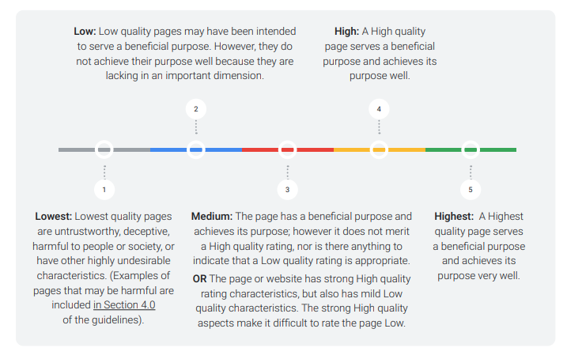

We strategized on several ways of improving. It’s hard to say which had the most benefit. Most likely, the overall picture of helpfulness improved for this site. Some of the improvements we discussed were:

* Using real human experience in their articles to add original content and reporting.
* Sticking to writing on content that was intensely relevant to their audience.
* Improving how they demonstrated their industry expertise to readers and also to Google including schema use.
* Removing content that was only present on pages to present keywords to Google. We all have content like this. No searcher who has Googled, “why won’t my lawnmower start?” wants to read an article with the history of lawnmowers and the many myriad of problems they can face. They just want a quick, trustworthy and helpful answer to their question. And they want to find it fast without having to read through unnecessary text.
* Understanding user intent and meeting it well.

They saw big improvements with the March core update. I expect the helpful content classification was lifted.

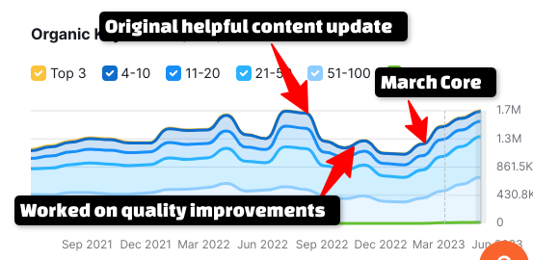

## How to know if you have been impacted by the helpful content system

There is no way for certain to know if you have been impacted. You can highly suspect an unhelpful content classification if you have a decline in organic search traffic that coincides with a known update to the helpful content system.

* August 25, 2022 - Initial rollout
* December 5, 2022 - Helpful content update

However, sites impacted on December 5 can be hard to diagnose as there was also a spam update that ran starting on December 14 and finishing on the same day as the helpful content update, January 12. In my experience so far in analyzing sites hit, if you think you were impacted by the link spam update, you likely were also impacted by a helpful content classification as well.

I was keeping [a list](https://www.mariehaynes.com/resources/algo-changes-and-more/) of suspected unannounced helpful content updates, but there are too many of them, so I am only logging the most obvious and significant for now. Here are some days on many sites were possibly impacted by the helpful content system:

* First week of November
* November 15, 2022 (many sites)
* Dec 5 (announced Helpful content update)
* Jan 4-6, 2023
* Feb 3, 2023
* Feb 16, 2023
* April 3-6, 2023
* May 1-3, 2023
* June 6, 2023

I’m just realizing as I write this that the first week of each month seems to be important for the helpful content system. Perhaps it updates monthly?

Here are some sites that I suspect are feeling the effects of an unhelpful content classification. To be impacted by the helpful content system, the losses do not have to coincide with an announced helpful content update:

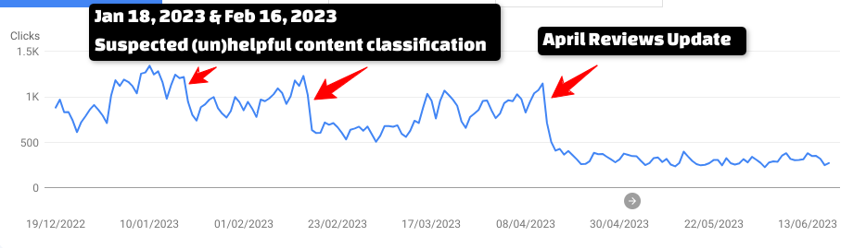

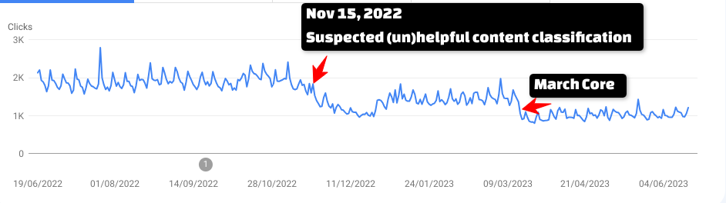

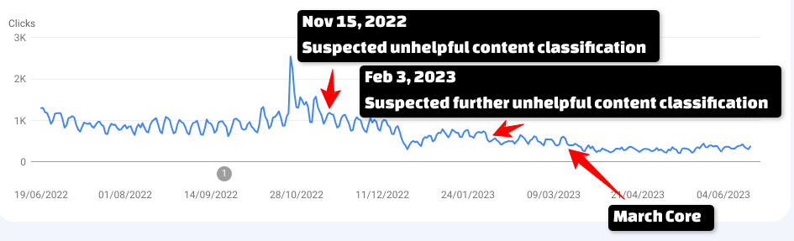

If your site has an unexplainable and sustained decline in traffic from Google, there’s a good chance that the helpful content system is to blame. Fortunately, we have guidance on what we can do to get this suppression removed.

## How to improve content quality

By now we can see the importance of having helpful content as we definitely do not want to have an unhelpful content classification weighing down our site’s ability to rank.

Google says, “A natural question some will have is how long will it take for a site to do better, if it removes unhelpful content?” which means that a big part of recovery is **removing** the parts of content that are unhelpful. We’ll talk about how to do that shortly.

Can you also improve by **adding** helpful content? Yes. Google told us in May of 2023 that the helpful content system will soon be “[working to identify and show more ‘hidden gems’ on Search](https://twitter.com/searchliaison/status/1658150965709615107?s=20)”, linking to this [document](https://blog.google/products/search/google-search-perspectives/):

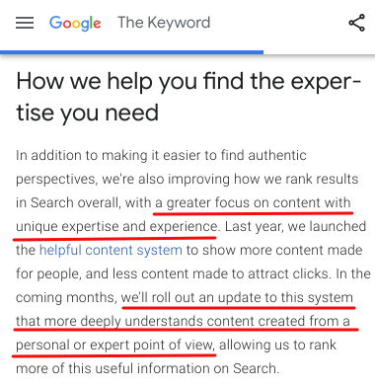

Google’s systems are designed to weed out the unhelpful content and further promote the stuff that is helpful.

We will soon look at understanding which content to remove. Then, we’ll focus on improving content. But in order to do this, we first need to understand user intent. Otherwise, how will we know which content is unhelpful to users?

## Understanding user intent

If you can grasp understanding user intent, you will have a much easier time meeting it! It’s not always easy though. User intent goes far beyond wide buckets like transactional intent or informational. Rather, what we’re trying to figure out is “Exactly what is it that this searcher is trying to accomplish.”

Your goal, for every single piece of content should be to produce something that really is the best option for people to land on. The thing is, often what *we* think is the best option is not what people actually want.

We can often get clues as to what searcher intent really is by looking at which content Google elevated over yours following a suspected helpful content suppression and seeing how it better meets a searcher’s immediate needs.

Let’s start by doing some research in the [Quality Rater Guidelines](https://static.googleusercontent.com/media/guidelines.raterhub.com/en//searchqualityevaluatorguidelines.pdf).

We’re going to work through Part 3: Needs Met Rating Guidelines in which the raters are given instructions on how to determine if content meets the needs of searchers.

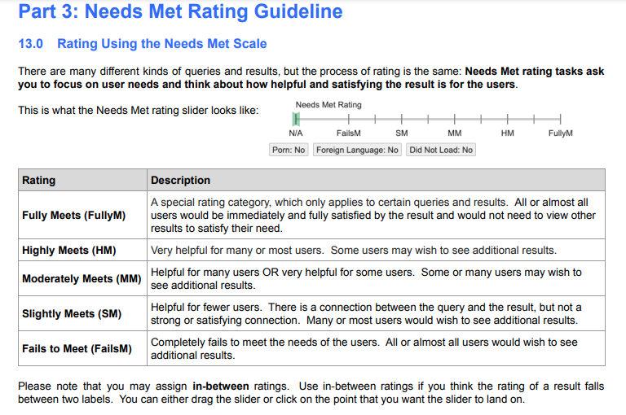

Again, I’d encourage you to write out your answers to these questions to help you solidify your understanding.

1. What does Google say the Needs Met rating task asks the raters to focus on?

2. What is content that Fully Meets the needs of the search who is “looking for a very specific fact or piece of information?”

3. Read through each of the examples in section 13.2.1. Explain why they fully meet the needs of searchers. You don’t need to write these down…but try to articulate it in your head before reading Google’s explanation in the “fully meets explanation” box.

4. In section 13.3, describe content that Highly Meets the needs of most users.

5. For each of the examples in 13.3.1, focus on understanding what the intent of the searcher is. Before looking at the third column, see if you can determine why the content is described as highly meets, but not fully. As you read the “Highly Meets” Explanation, jot down notes for your website.

Note, these are generally pictures of search results, not actual pages. Still, what we put on our pages influences what Google can put in the search results. If, for example, Google is not able to extract information about our business hours when that’s what searchers are looking for, then we may need to look at whether we’ve displayed those hours on our website.

I’d encourage you to make your list before reading mine.

Now that you’re finished, read through the things I learned and see if our lists are similar:

* When someone searches for my business, are they looking for contact info? Does the info Google displays give the searcher what they are looking for? If not, can I change my site’s content to improve the way Google displays my business by perhaps adding more information on our home or About page?
* When someone searches for the answer to a particular question, do I have content on my site that directly and clearly answers that question? If the content is there, is it possible it could be rewritten in a way that is easier for search engines to grab? *hint: You can ask ChatGPT or Bard, “Take this text and rewrite it”. Because it uses natural language processing (NLP) and because search engines understand NLP, your text is more likely to be understood by search engines.*
* Do users have to work hard to find the answer to their question on my page? A good tip here is to search for your keyword and see where on the page the answer is on the top ranking sites as compared to yours. Often you’ll find that users have to do much less scrolling, skipping ads, etc. on the sites that Google is preferring. If that’s the case, that could be a clue that you need to tone down your ad use.
* Could better use of unique and helpful images or video improve my ability to meet user intent? Could better words and descriptions around my images help users?
* Could I add more examples, especially based on real life experience, to help meet searcher needs?
* If users are confused about a topic, have I accurately understood where the confusion is and how to explain both sides?
* Are searchers more likely to be looking for historical information or fresh news on a topic? Should I add either to make the content better?

6. It is interesting to read through the Moderately Meets and Slightly Meets examples. Google says, “Moderately Meets results are generally average to good.” If all of your content is generally average, I suspect you are feeling the effects of an unhelpful content classification.

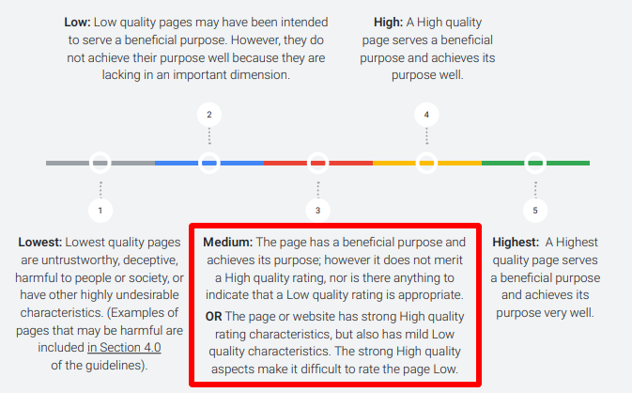

As you did previously, study each example.What is the searcher trying to find? Why did Google label the example of results given as “Moderately Meets” and not fully or highly?

Some of my notes:

* If a searcher is looking for an official resource or website, it will be difficult for me to convince Google to rank my content above that site.
* If there are lots of pages on the topic I am writing about, is my content clearly substantially more helpful or valuable? If not, is it possible for me to achieve this goal?
* Are users likely to have more questions directly related to their intent that I have not covered?
* Do I have articles that give stale information? Can I update them?
* Is there information on my pages that distracts the searcher from finding what they are looking for? Ads and supplemental content are ok, but if they annoy searchers or make things difficult, that’s not good.
* Is it obvious to a searcher that the answer they are looking for is on your page?
* Is the quality of writing what the searcher would expect?
* When I search for my main keyword, does the snippet of information Google shows contain enough information to satisfy searchers?
* Is a searcher looking for a direct answer likely to be confused by my page?
* Do I have titles that are contradicting the content on the page or designed to bait clicks?

7. Fails to meet examples are interesting to examine. These are less likely to be a concern for your website. Many of the examples are showing Google ranking content that isn’t the right answer to a question. I think it’s possible that when a rater labels content as “fails to meet” these can be used as examples of “unhelpful results”. Many are examples of inaccurate and untrustworthy content.

Read through the examples. Focus on understanding user intent and what kind of content would likely meet that intent.

Some things I learned:

* Content that contradicts well-established consensus can be considered “fails to meet”.
* Inaccurate content is not good.
* Do not spread disinformation, intolerance or hate. I should add that this includes your comment sections.

8. Read through section 14.0 - The Relationship between Page Quality and Needs Met. Once again we have examples to go through!

Look at each of the examples of Needs Met and Page Quality and ask yourself if these could apply to your site and its content. Again, a few of the things I thought worthy of consideration:

* Am I making attempts at humor that could be perceived as bad advice?
* Could Google consider me not reliable enough to rank for YMYL queries? If so, removing YMYL content written without expertise is important. Or, in some cases, having legitimate experts write, edit or fact check content could help.

## Removing content

Removing content might mean removing entire pages from search (by adding a noindex tag), removing them completely from your site (with good use of redirects) or removing just sections of content that are not really helping searchers and making the helpful parts more obvious.

Things you may consider removing or changing:

* Content that distracts the user or makes it difficult for them to quickly get the answer to the question they came to your site to find. This could be ads, walls of text, or popups. None of these are inherently bad on their own. Google knows sites need to monetize. The goal here is to decide whether their presence is hindering the searcher’s ability to quickly get their needs met.
* Content on YMYL topics despite lacking expertise. I have advised several sites to completely remove sections of content that are clearly outside of their area of expertise.
* Attempts at humor or sarcasm that could be perceived as real advice.
* Content that contains inaccuracies or significant spelling and grammar errors.
* Content that is essentially as good at everyone else’s and not substantially valuable on its own. This is a problem for many sites that have outsourced content production. If you have large amounts of content that was written by an SEO agency on your behalf, you may find that this is causing an unhelpful content classification.
* Content that is outdated. Not all outdated content is bad. My philosophy is that if content was useful at one time, then it should stay on my site. But, if that content is causing people confusion because it’s not up to date, then improving it so that it’s relevant should be a priority.
* Content that promises an answer but doesn’t deliver.

Removing content is often not a task to take lightly. You likely don’t want to remove pages that have good, authoritative links pointing to them….although my bet is that your lower quality content likely doesn’t have legitimate authoritative recommendations via links.

I have not covered the specifics of removing, noindexing, redirecting, preserving internal linking and so on that go with content pruning. If you are considering a large content prune, there are many things to consider here and this is not something I’d recommend doing without professional guidance.

In some cases, we might consider removing *sections* of content rather than full pages.

### Removing or moving sections of content

In examining example after example of content that performed well or poorly following a possible unhelpful content classification there were many cases where I recommended removing large chunks of words very few readers are likely to read.

Why do we have words like this on our pages? The page on the left is a site impacted by the helpful content system - on the right, a competitor who was consistently promoted ahead of them. The query in question is **rose bouquets**. The intent of the searcher who lands on these pages is to order a rose bouquet. No searcher wants to read through these words. They are a distraction that is keeping them from achieving their goal. Yet, this type of text on a page is relatively common as we all know that search engines use words in order to understand if content is relevant.

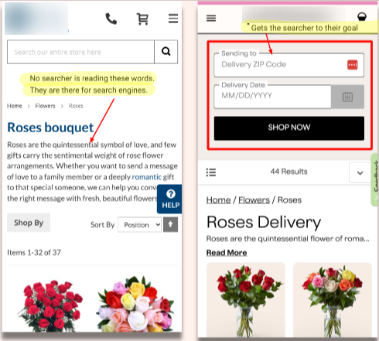

For each and every one of your pages, I’d encourage you to go through the following steps. This is all a part of the process we’ll go through at the end of this document.

1) Determine user intent. What are the immediate needs that they want answered? Not all of their needs - focus on the **most immediate need** that they have. You need to be the best answer for that need.

2) Determine which part of your content best meets that intent

3) Make it incredibly easy and clear for searchers to find it. It doesn’t necessarily have to be at the very top of your page. In some cases a link, like a “jump to recipe” link may be fine. I encourage you here to look at the pages Google currently is ranking. Ask yourself how they possibly get the searcher to their answer more quickly.

### You will have difficult decisions

What should my client do in order to get the helpful content classification removed from their site? One of the most difficult things here is that in order to remove the classification we have to make many assumptions about what it is that is causing it.

There are several changes that could help this site, a legitimate real world business, look better in the eyes of the helpful content system. But it will be difficult for them to decide what to do, especially considering that their revenue from Google has declined rapidly.

They need solid guidance. But, there are no case studies, tests, or official guidelines on what to do if you have been impacted by a helpful content classification. The way Google’s algorithms work, it is not even possible to know with certainty *if* your site is being suppressed by this system. All you have to go on is observations and advice from people like me who are interested in helping people but receiving too many requests for help to dedicate the hours required to put together a solid case study.

In the case we’ve been discussing, here is what I believe will improve this site’s chances of improving in the eyes of the helpful content system:

* Review all blog content. We’ll want to figure out what content searchers are truly engaging with. Strategies we could consider include:
  + Removing the blog
    - Pro: If the content that was written by SEO companies is the culprit of the unhelpful content classification, then removing it could be beneficial.
    - Con: This content could be contributing to topical authority. Removing it could be detrimental.
* Keeping the best content on the blog and working through my checklist of understanding and meeting user intent to improve content. We could then create a strategy around this content to create even more helpful content on these topics to build more topical authority.
* Redesign product pages with user intent in mind.
  + Pro: Will make pages more helpful
  + Con: Proper UX testing and design will be an expensive change. This will be a difficult decision for a company that is seeing less and less online revenue.

This site also has some decisions to make re disavowing. They benefited for years from what many would call “white hat” link building, mostly in the form of writing articles to get them published or mentioned on other sites. They likely won’t benefit from disavowing as it won’t cause those links to start counting again. But once again, there is no way of knowing whether past SEO efforts are actually sending Google a signal that says, “Hey, this site participates in link manipulation, so let’s be cautious about ranking them highly.”

Perhaps filing a thorough disavow will help? This again, is a service that requires hiring a professional at significant expense, with no guarantee that it will help.

At the same time, these difficult and impactful decisions are going to be made even more difficult as the entire online search landscape is about to change. Google is testing adding [AI generated answers to search](https://static.googleusercontent.com/media/www.google.com/en//search/howsearchworks/google-about-SGE.pdf). In April of 2023 the New York Times reported that Google was working on an [entirely new search engine](https://www.nytimes.com/2023/04/16/technology/google-search-engine-ai.html) that isn’t just AI enhanced…it is built on AI. The goal is to “offer users a far more personalized experience than the company’s current service, attempting to anticipate users’ needs.”

I expect that sites that perform well under the current helpful content system will be the ones that are most likely to do well in this new search engine, but this is all speculation.

Decision making will be so difficult for many businesses.

### De-wordifying your pages

I made that word up 😂

Here’s something you can try if you feel you have pages with loads of words that searchers need to read through in order to get their question answered. Prompts like this sometimes help me distill down exactly what it is that I need to write about. Then, if it makes sense for the page, I can take the paragraph ChatGPT or Bard gives me and either use it or modify it.

For a few of your pages, try this experiment.

Use [Bard](https://bard.google.com/) or [ChatGPT](https://chat.openai.com/) to try and determine the questions your searchers have on a topic. We’re not trying to answer *every* question, but the absolute most important things that are relevant to their query.

Try this prompt:

*A customer is coming to my website with the intention of [...]. Tell me the three most important things they want to find on this page. Consider what questions are most important to a searcher on this topic. Then write a brief introductory paragraph that does well at either addressing and answering the searcher’s concerns.*

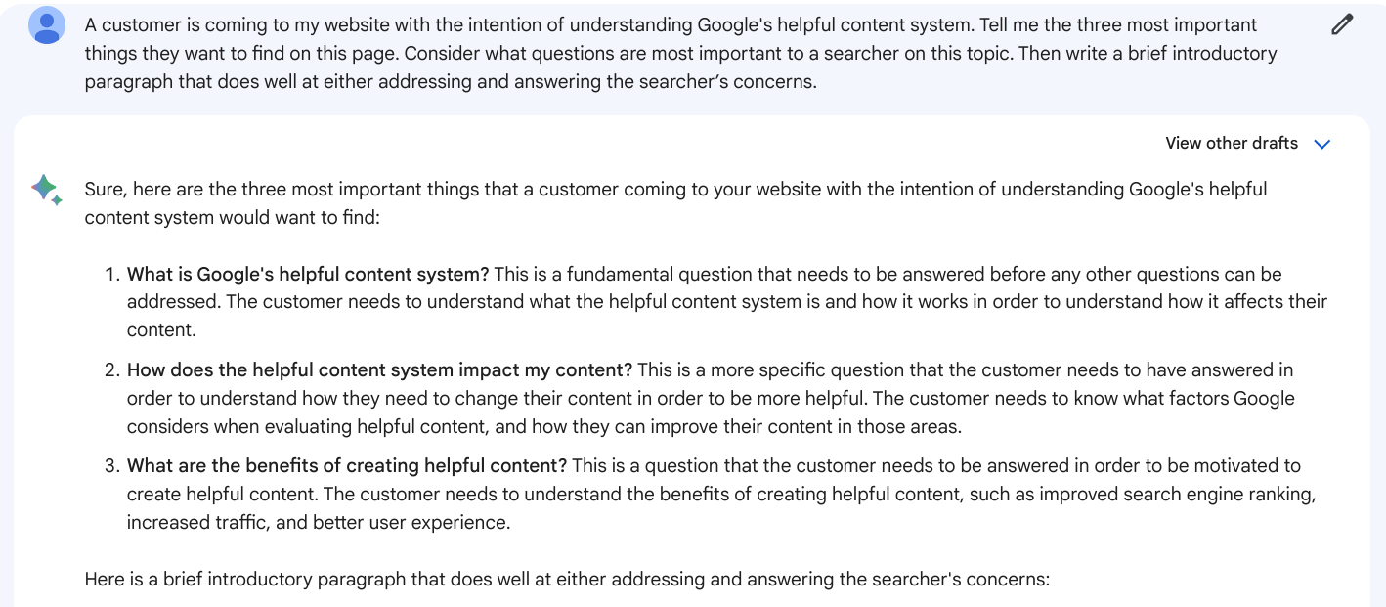

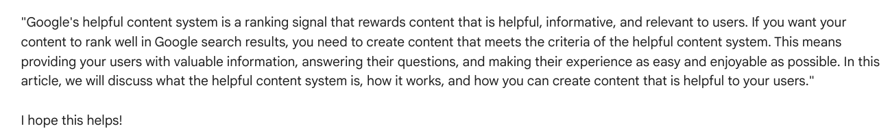

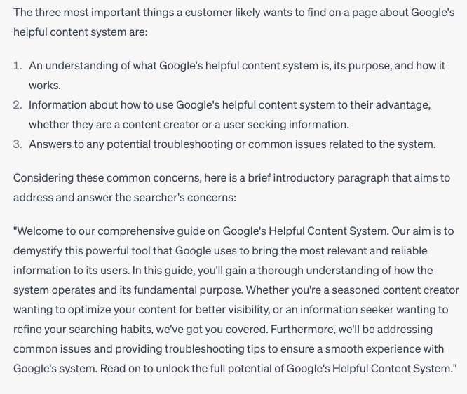

Another prompt I like to use after doing this is:

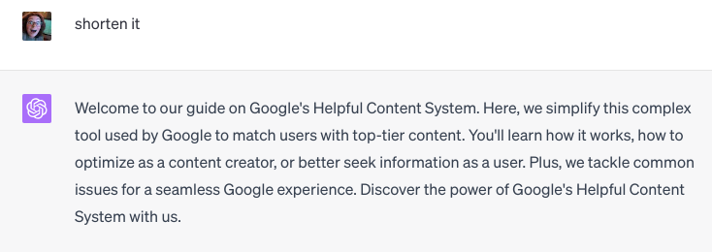

You can also work with this even more…

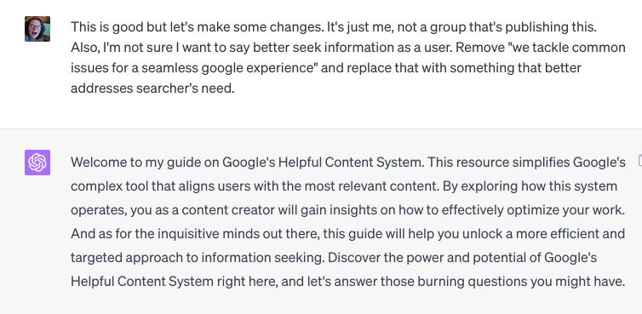

Here’s what you read at the beginning of this guide. This paragraph explains this document and addresses each of the concerns most readers on this topic have.

“Welcome to my guide on Google's Helpful Content System. This workbook simplifies Google's complex system that aligns users with the most relevant and helpful content. By exploring how the helpful content system operates, you as a content creator will gain insights on how to effectively optimize your work. “

If I were writing an article for my website (as opposed to a wordy workbook), I’d try to limit this article to only focus on the aspects that are important to a searcher.

You can once again turn to ChatGPT for ideas for headings and rewrite your article to only include information that falls under these headings. Any other info on this page is related, but not necessarily relevant to its target audience.

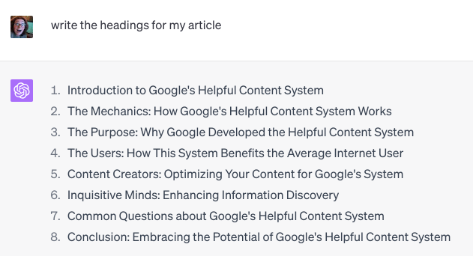

Rewriting pages with this method takes time, especially when you take into consideration everything we will soon cover in a checklist.

However, it can work well. Here is an article on my website that I optimized in this way. Within 5 hours of republishing it, it improved in rankings and started to get traffic. This may not seem like many clicks, but these clicks have resulted in significant revenue for me.

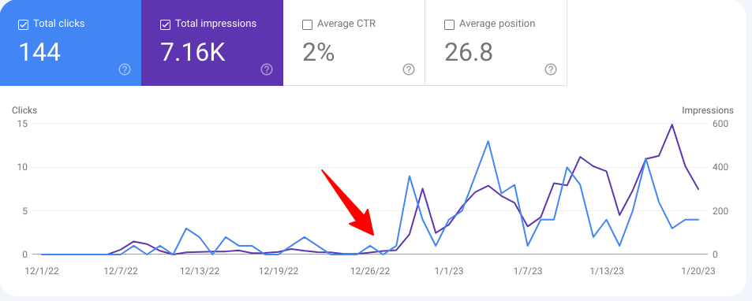

## Page experience

As we’ve just touched upon, page experience is incredibly important. Google’s documentation tells us there are several things that can contribute to overall good page experience. I’ve underlined what I think is most important:

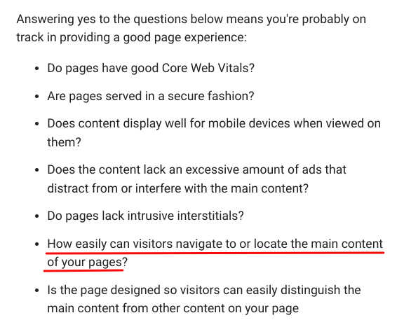

[Core web vitals](https://web.dev/vitals/) are metrics we should strive to improve. Users like pages that are fast and don’t jump around. Google gives us core web vital scores we can aim for along with ideas for improvement in the Page experience report in GSC. Your goal should be to have scores that are considered good:

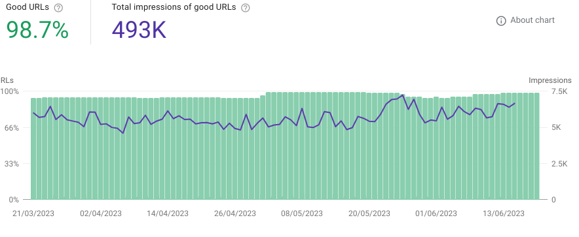

If you have a lot of pages that have a poor or failing score on core web vitals, then this is sending a signal to Google that unless your content is substantially better than what exists, users may prefer to see other pages than yours.

In May of 2023 Google announced a new core web vital that looks important, [Interaction to Next Paint](https://developers.google.com/search/blog/2023/05/introducing-inp).

What about ads and their impact on performance? It’s ok to have them. But if they are annoying users or distracting them from the main content, this could correlate with unhelpfulness.

Homework: Read Google’s [documentation on page experience](https://developers.google.com/search/docs/appearance/page-experience).

**I thoroughly believe the most important component of page experience for every page is how easily the user can find their answer on your page.**

## Improving helpfulness by adding content / improving E-E-A-T

There are so many things we can do to improve our chances of Google’s models considering our content the type of content that is likely to meet the needs of searchers.

Let’s start by working through section 17.0 of the QRG: Specificity of Queries and Landing Pages. In this section, Google is helping us further understand when the intent of the searcher could be best met by content exhibiting E-E-A-T. It also gives us clues as to what kind of signals Google could use to assess E-E-A-T.

Go through each example and ask yourself whether it applies to your situation.

Some things I learned from the examples in this sections:

* They call Visa a “credit card company with high E-E-A-T.” If the pages Google is ranking for your queries are all companies that are well known for being an authority, you may find it difficult to compete for these queries. There might be exceptions if you are able to provide content that is even more helpful than what currently ranks. However, Google’s algorithms have chosen to weigh brand authority and recognition as important for your queries, so it may not be possible for you to rank here.
* Being popular speaks to your reputation.
* “Good reputation” is mentioned. The more you can do to improve your reputation for being known as a topic expert, or for whatever it is your customers find important (expert service, knowledge, etc.) the better.
* Having the same value in your content as others only really works if you are popular for your topics.

## Popularity

Reputation is more than just having good reviews online. Your goal should be to be popular for your topic - to be known as an authoritative source. The word “popular” or “popularity” is in the QRG a lot. Here are a few places where raters are taught the importance of being known for your topics:

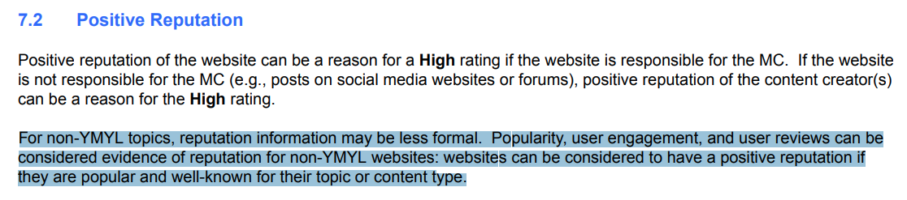

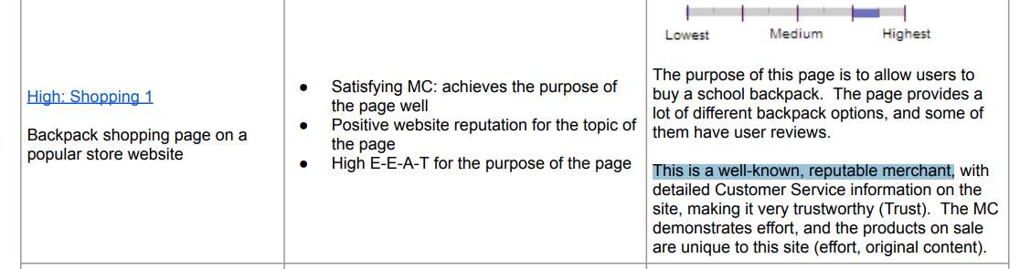

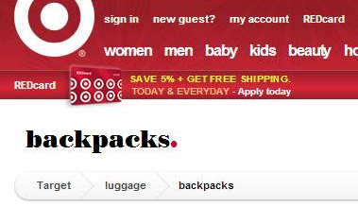

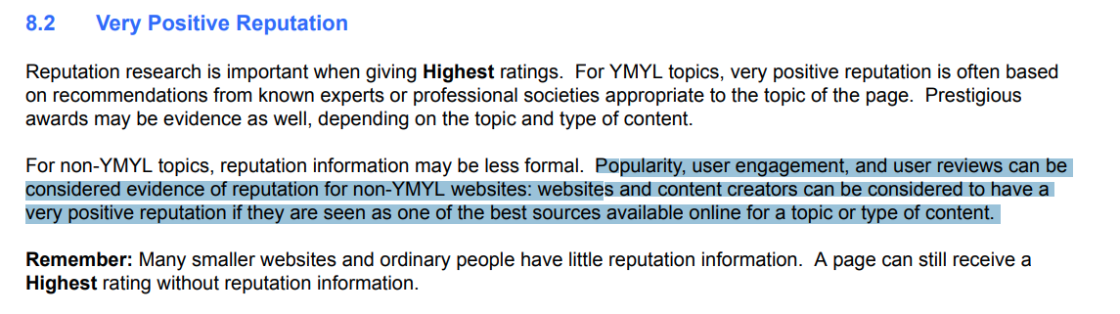

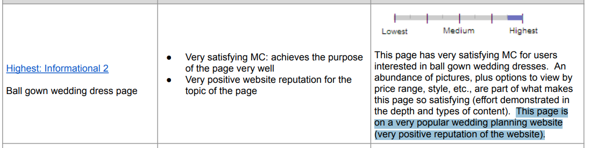

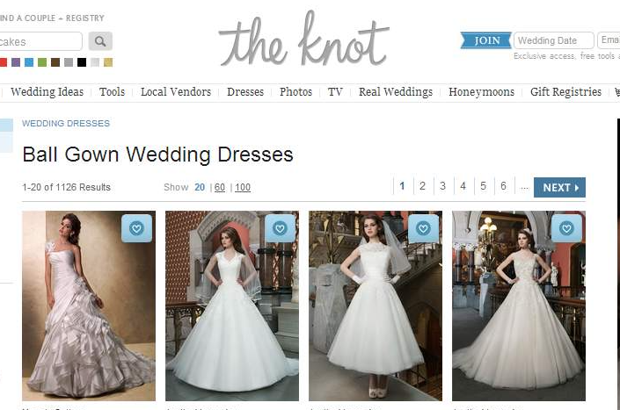

In many cases, a signal indicating popularity is the number of user reviews:

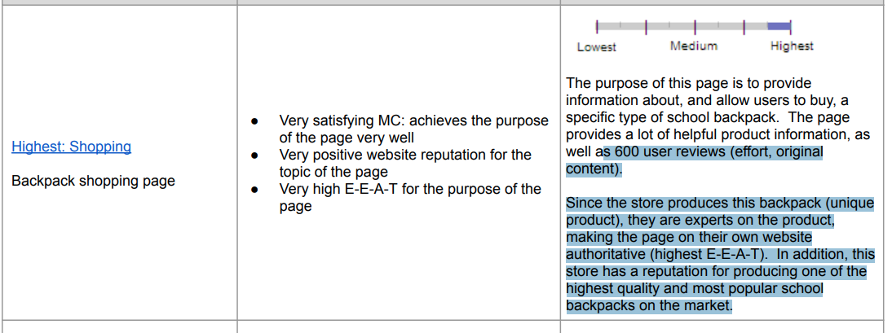

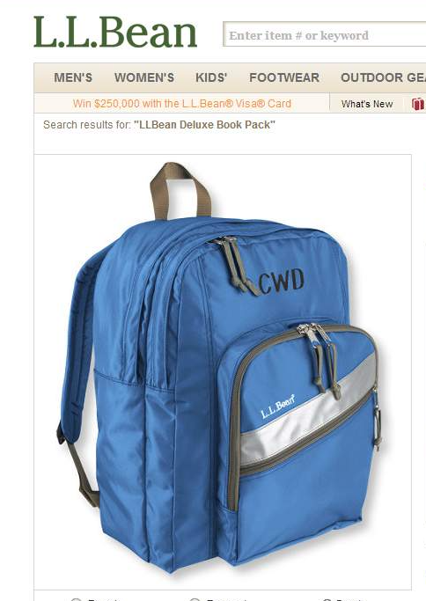

Reviews and other information online is gathered to determine whether businesses are seen as trustworthy:

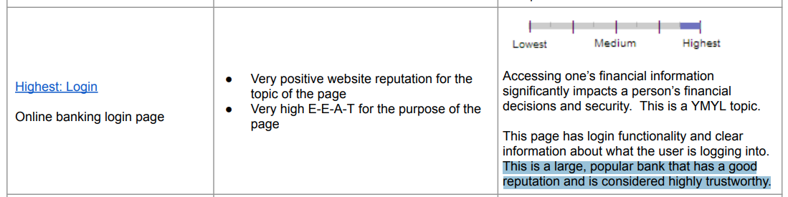

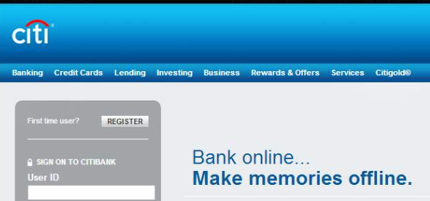

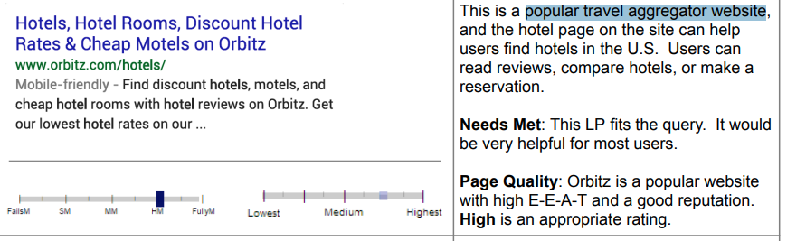

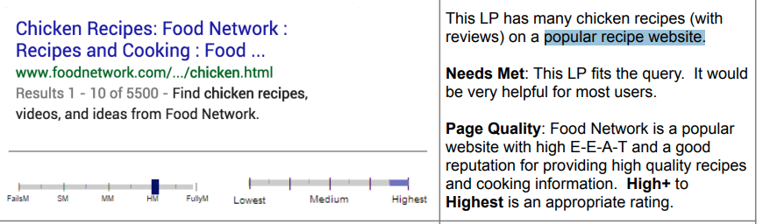

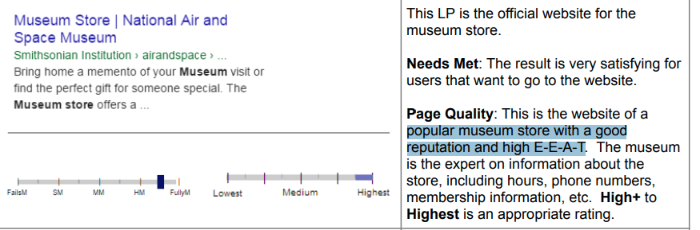

Popularity matters for local recommendations. One of the keys to being recommended by Google as a local business is to actually be a place where people tend to go!

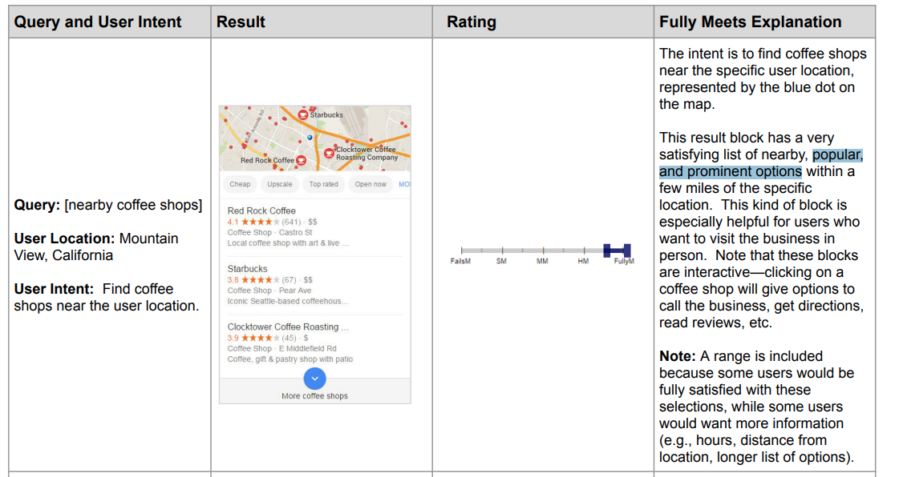

To understand how to improve popularity, let’s look at this documentation from Google on [the knowledge graph.](https://blog.google/products/search/introducing-knowledge-graph-things-not/) In doing so, we can understand a little bit more about how information like popularity and reputation can be stored by Google and used as needed.

Answer the following questions based on the knowledge graph article:

* How many objects and facts are in the knowledge graph? It is wild to think that not only are there are this many things in the knowledge graph, and also that Google understands the connections and relationships between them.
* How does Google know which facts are needed in the knowledge graph for each item?
* What does Google say is “the key” of the power of the knowledge graph?
* What does Google say the perfect search engine should do?

Now let’s look at the shopping graph. It’s similar to the knowledge graph, but focused on information about products. Even if you don’t have a shopping website, it is possible that the reputation information stored in the shopping graph is relevant to how Google understands your business and its reputation.

Read this [article on Google’s shopping graph](https://blog.google/products/shopping/shopping-graph-explained/) and answer the following questions:

* The Shopping Graph is Google’s ____ - powered real time data set of the world’s products and sellers.
* How many product listings does it hold?
* What kind of information about those products is in the shopping graph?
* Where do the product listings in the shopping graph come from?
* What kind of relevant information does the shopping graph pull from the web? Can you make better use of any of these? The more information we can feed the shopping graph the better.
* What kind of information on trusted sources on the web does Google draw from?

The shopping graph contains all sorts of information about entities (your business name, people associated with it, etc.) and what can appear in search results. As does the knowledge graph.

Now let’s talk about this paper that describes an even bigger knowledge graph - the [knowledge vault.](https://research.google/pubs/pub45634/) I’d encourage you to read through the [paper](https://storage.googleapis.com/pub-tools-public-publication-data/pdf/45634.pdf) describing this vault. It blew my mind to read about how they decide what to put in the graph and the challenges they face. We do not know whether Google is currently using it. In 2014, Search Engine Land reported that the [knowledge vault was likely going to power AI driven search in the future](https://searchengineland.com/google-builds-next-gen-knowledge-graph-future-201640). However, Google asked SEL to add a disclaimer to their article saying that at the time, the knowledge vault was only a research paper and not an active Google product in development.

There likely is also a social graph. Google has not said much about using a social graph, but they did publish [this patent](https://patents.google.com/patent/US8306922) which hints at it.

Why are we talking about all of these graphs? Whether information is stored in a knowledge graph, shopping graph, social graph or even the knowledge vault, the thing to know is that Google has multiple graphs that are a collection of all of the important information on the web in regards to every entity that’s important to record. The graph is filled with connections that allow Google to answer questions based on the breadth of the knowledge of the internet.

More reading:

[Google unveils its Shopping Graph, an expanded Shopify integration and more shopping features at I/O](https://searchengineland.com/google-unveils-its-shopping-graph-an-expanded-shopify-integration-and-more-shopping-features-at-i-o-348735) on Search Engine Land

[How Google’s knowledge graph works](https://support.google.com/knowledgepanel/answer/9787176?hl=en) - Google documentation

[Introducing the Knowledge Graph: things, not strings](https://blog.google/products/search/introducing-knowledge-graph-things-not/) - Google documentation

[Evaluating the Knowledge Graph vs. Social Graph](https://www.searchenginejournal.com/knowledge-graph-vs-social-graph/56504/) at Search Engine Journal

Watch this Stanford Seminar where Google’s Xin Luna Dong describes the Knowledge Vault, including how they know which information to put inside of it.

<https://www.youtube.com/watch?v=Z6tmDdrBnpU>

There is so much we can do to improve our presence in the knowledge or shopping graphs, and also Google’s understanding of our businesses' aspects, topic areas and popularity.

One of the keys to improving E-E-A-T, which in turn improves the chances of our content being seen as aligning with Google’s ideals of helpfulness and quality, is to improve our presence in the knowledge graph.

### Using our knowledge of the knowledge graph to improve E-E-A-T signals

Many of Google’s questions in regards to [helpful content](https://developers.google.com/search/docs/fundamentals/creating-helpful-content) are about information that likely uses these graphs.

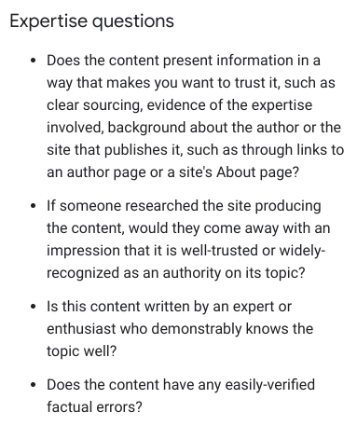



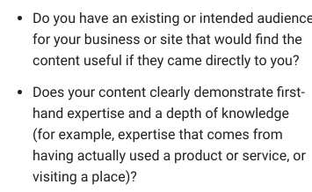

Here are some ideas for things that you can do that may improve your presence in the knowledge graph and in turn, Google’s assessment of E-E-A-T for you, your authors, your business and your content:

* Make good use of author bios. This webinar is a few years old, but still relevant. I answered a lot of questions on [good use of author bios](https://www.youtube.com/live/8JH0XXyn4PQ?feature=share). If you’re not sure if you should be using author bios, ask yourself, would having a description of the person who wrote this content help users to trust it? Do users care about the expertise of authors? Would sharing about the author’s real life experience on this topic make this post more trustworthy? Is Google ranking similar content that has author bios? Don’t get too stressed about what wording to use. Your goal should be to clearly communicate why this person is qualified to provide advice on this topic. Link to a more thorough author page on which you share as much as you can on their qualifications, awards won, mentions and so on.   
    
  Tip: Try using ChatGPT or Bard to help you write your author bio. You can paste in your current author bio and ask, “Rewrite this so as to better demonstrate this author’s experience on the topic of [the topics they want to be known for.]
* Consider hiring authors with more expertise and experience. You are looking for writers who truly know your topics…not just ones who can regurgitate and aggregate information that already exists online. Medical reviewers added alongside an author may be helpful. But, if you’re going to do this you need to actually have the reviewers reviewing and improving content based on their expertise.  
    
  I expect we will see changes in medical writing online. Many of today’s medical articles are written by people who have a degree or an online presence for being known on writing on a topic, but are severely lacking real world experience.
* If you are lacking in expertise, but have topical experience, consider adding quotes or interviews from true experts. This is unlikely to make your content *significantly* better than content that truly is expert written from the start, but it may help somewhat. If your content is consistently more helpful than what the actual experts are writing, this could give you an advantage.
* Find ways to get the sites that matter in your industry to link to you. Don’t build links…instead, build reputation and recommendations. Here’s a [video I recorded with Moz that might help give you some ideas](https://moz.com/blog/what-links-comply-googles-guidelines-whiteboard-friday). Or, you can reach out to me and I can connect you with a PR professional.
* Consider <gasp> guest posting. Not for the links. But rather, for the type of mention where you can say, “Oh wow, we got featured on *this* authoritative site in our vertical.” The more you get published with your name associated with your topics, the better provided the sites you are getting mentioned on are ones that readers of your topics frequent.
* Do things to get mentioned in the news. Fresh authoritative mentions of your brand speak to your E-E-A-T.
* Consider schema use. Schema, or structured data can be added to a website to help search engines better understand your business, the entities within, and the relationships that matter. For example all of the following have the potential to help Google find the signals that contribute to your legitimacy:  
  + [Organization schema](https://schema.org/Organization) use can help Google understand your business better.
  + [Product schema](https://schema.org/Product) helps Google know more about products.
  + [SameAs schema](https://schema.org/sameAs) can help Google identify where your authors have been featured in authoritative places related to your topics.
  + [Event structured data](https://developers.google.com/search/docs/appearance/structured-data/event) can not only [help your events be discovered in search results](https://developers.google.com/search/case-studies/eventbrite-case-study), but it may possibly send signals of legitimacy. It makes sense to me that a business that regularly holds events is one that is legitimate and popular.  
      
    Is it worth the time spent adding schema? I am torn here. There are some case studies showing how extensive schema markup appears to have helped improve rankings. For example, Dixon Jones wrote an article showing that sites making use of [About](https://schema.org/about) and [Mentions](https://schema.org/mentions) markup to help Google better understand their topic, did well.   
      
    It is hard to conclusively say whether adding schema has helped my clients as it’s rare that we *only* worked on adding schema. [Schemantra](https://www.schemantra.com/) looks like a good tool to help you build out schema if you’d like to try this route. My thought is that right now, adding schema may help Google better understand your site, your topics and your E-E-A-T and may give you an advantage in search. However, Google’s goal is to understand the web *without* markup. I do not expect adding schema will have much benefit for much longer. If you’ve got the time to play with schema, go for it…and please send me case studies! If you’ve got limited time, I’d recommend focusing more on improving overall helpfulness than adding schema.
* Create topical authority to demonstrate a deep level of knowledge on your topics. Topical authority is a hot topic lately. There are people in SEO who are doing interesting work in thoroughly understanding and covering every aspect of your content to build topical authority.   
    
  This is because there is a topic layer in the knowledge graph.  
    
  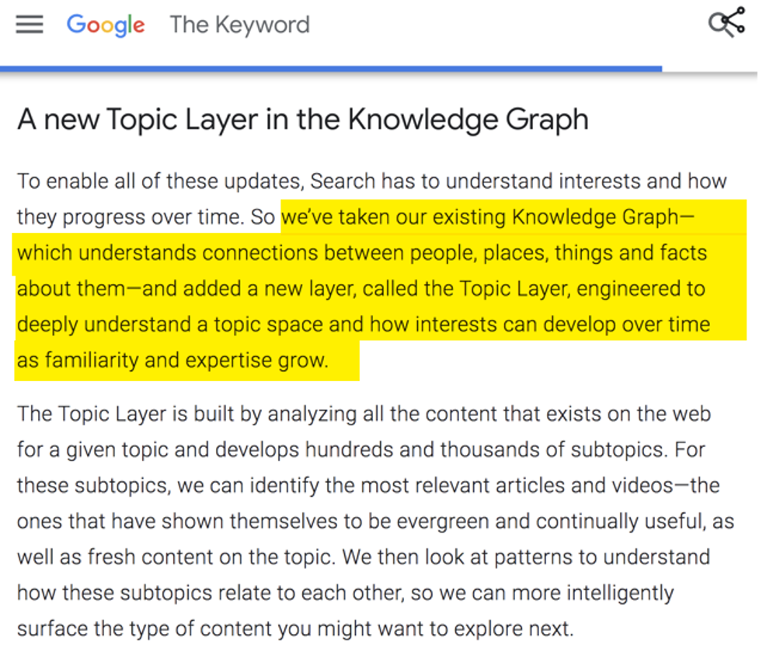  
  Some sites appear to be benefitting from trying to create topical authority using blackhat methods of creating copious amounts of content, all semantically relevant and related and interlinked in such a way as to build topical authority. I would urge you not to be tempted to create content for the sake of search engines. You are just asking for a helpful content classifier once Google’s systems spot the patterns of manipulation.  
    
  Rather, make it your goal to do the following:  
  + Curate a list of the most important topics to your audience
  + Write content that meets the needs of your searchers
  + Make good use of internal linking and content hubs. The idea is to have a central hub for a main topic and then have several supporting related posts that all link back to it. Again, these supporting posts should have value on their own and not just be there to try and artificially create topical authority.
  + Continually update these articles or add to them when there is new and relevant information on your topics.

You can build topical authority by consistently producing content that searchers interested in your topic find helpful. There are likely ways this can be optimized with good use of internal linking and site structure. I hope to explore this more in the future.

## Freshness

For many queries, content that is fresh is more likely to be relevant and helpful. I’d recommend reading section 18.0 where the guidelines speak on this type of query.

For your content, ask yourself these questions:

* Could this page be improved by adding more up to date information?
* Do you have the most up to date information?
* Do you have outdated information?
* If you have content describing outdated product models, can the searcher easily find the info on the most recent model?

You don’t necessarily need to delete old content. If it was useful to searchers in the past, it’s not likely to hurt your site today.

## Products

If you sell or write about products, review section 21.0 of the QRG called Product Queries: Importance of Browsing and Researching.

The main focus of this section is determining whether the intent of the searcher is met.

One thought I had after reading this section:

* Are you creating content for searchers with a “know” intent such as [buy ipad] or “do” intent such as [ipad store apple.com]. This is important. If your searchers are coming to your pages with the intention of buying a product, then the most important thing on that page should be making it easy to purchase that product. If they are primarily reading your content to learn something, the most important thing you can do is answer their immediate questions clearly, concisely and quickly.

### Product review criteria

If you sell or write about products, services or anything that is helping people make a decision on how to spend their money, you have an additional set of criteria to review. Google has an entire document on the criteria of high quality reviews:

[Write high quality reviews](https://developers.google.com/search/docs/specialty/ecommerce/write-high-quality-reviews)

I have not thoroughly covered these in my checklist, but they are extremely important!

# Checklists to work through

## Needs Met

Now that we understand how the helpful content system works and have studied what the rater guidelines say about quality, let’s work through Google’s documentation on [creating helpful content](https://developers.google.com/search/docs/fundamentals/creating-helpful-content).

### Which pages to analyze?

If you have been impacted by an unhelpful content classification, you will likely need to make significant changes across the majority of your content in order to see recovery. In most cases I recommend starting with your most important pages. Go to GSC and work through pages in order of clicks. Once you have worked through a few, you should be able to see patterns that you can apply to all of your content.

In some cases it can be helpful to analyze your pages against a competitor whom Google has elevated at the same time as your losses. If you are an Ahrefs customer, I have found it helpful to use their position history data. It often makes it easy to see what Google is now preferring. In the case below, my client (in pink) was clearly being beaten for this keyword by authoritative sites. This is a keyword they likely should not spend more time trying to rank for.

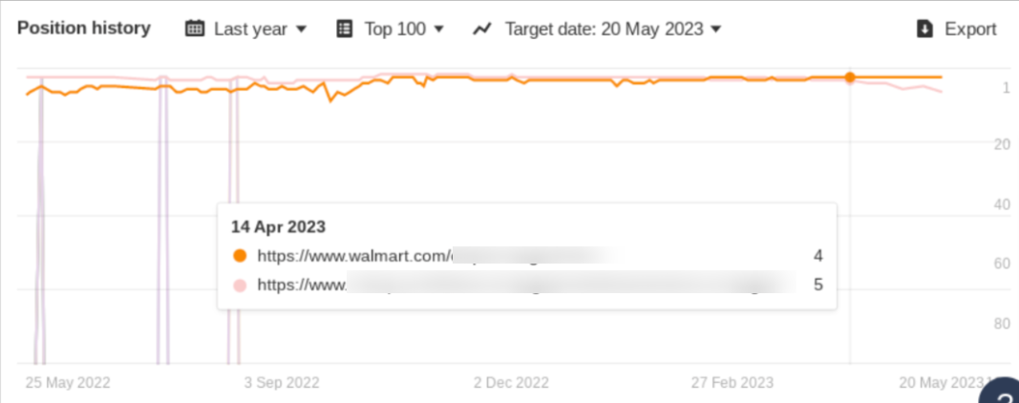

Start with a page that is one of the most important pages on your website. Our goal here is to do everything we can to align with the ideals of quality Google has described in the rater guidelines and in their helpful content documentation.

Answer these questions. Then, we’ve got even more of a checklist to review after these!

## Understanding Intent & Providing the best page experience

For searchers who land on this page, what is the most important thing they are trying to accomplish?

| A searcher who lands on this page wants to… |
| --- |

What are 2-3 questions that are most important to this topic? For example, if one of the page’s top queries is “buying a diamond”. Bard and ChatGPT can be useful here alongside your expertise on what is important on your topics.

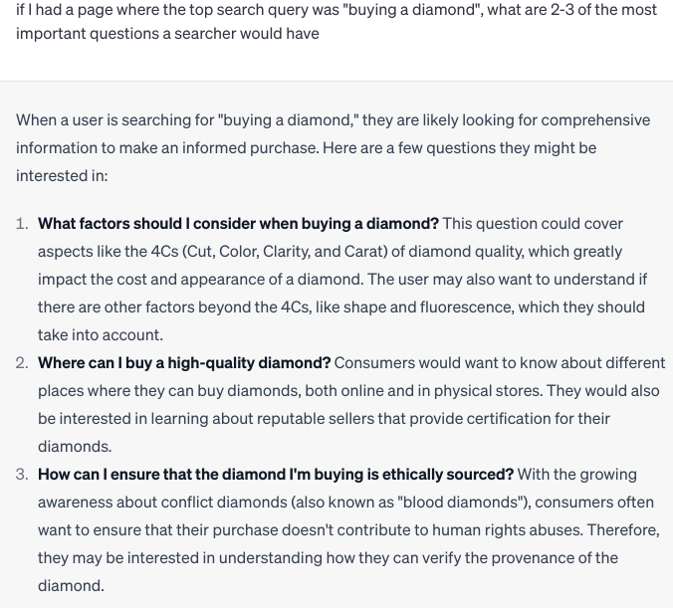

Now ask yourself this question:

If a searcher lands on my page (especially on mobile as Google evaluates the web on its mobile first index), are they quickly convinced that the answers to these questions will be easily found?

How do the pages that Google is currently ranking compare here? Can I make improvements to better convince the searcher of the value on this page? This could include things like:

* Doing a better job at understanding and answering the important questions.
* More concisely answering the questions.
* Answering the questions higher up in the content or in a way that is easier for searchers to locate.
* Making use of graphics, images, charts, tables, and so on to make the answers to this question easier to find.

| Do competitors do a better job at quickly meeting immediate searcher needs? |
| --- |

| How could we improve this page to better convince the searcher that the answer to their question is here? |
| --- |

Another thing you can try is looking at the GSC query data for this page.

| What are the main queries bringing traffic to this page?  For each, does the page concisely and quickly meet their need?  Note: If you have a page that is ranking for several types of intent, it might be worth considering whether to create two separate pages to better serve users. |
| --- |

## E-E-A-T - Helpful, high quality content

## Content Quality

Now let’s work through the helpful content questions. For each of these we will compare our content against the pages that Google is currently ranking in top positions for our main search queries.

For each page you will need:

* an important query
* a list of who is currently ranking for that query
* an understanding of what the searcher is trying to achieve when they land on your page

| Compared to what currently ranks, does your content provide original information, reporting, research or analysis?  If not, how can you improve it? The goal is not to put *as much* content as possible on a page. It is important that what you add is truly helpful to meeting the main search intent.  Can you add:   * a study * an experiment * an interview * a video * images * in depth research that you can’t find on other sites |
| --- |

| Is this a topic where a searcher would find a complete, substantial and comprehensive description of the topic useful?  If so, what are the most important aspects of this topic that should be covered?  Do competitors do a better job? What have they covered that directly answers user intent that you have not? Should you add to your article?  Tip: Use ChatGPT or Bard here to generate ideas. Paste your content in and ask, *What is the main topic of this content? Is the content complete, substantial and comprehensive? What could be added to it to make it more useful.* |
| --- |

| If lots of people are writing on the same topic, you need to convince Google’s algorithms that your content is insightful enough to show it alongside everyone else.  What do competitors have on their pages that could be considered insightful and interesting?  What can you add? |
| --- |

| This is a big problem for many sites! If you are covering a story that you did not break, are you adding enough value to your version of the story that a searcher would find it useful alongside the originator?  If most of your content is essentially rewriting what others have said, this is a situation where you may want to consider (with careful judgment) removing entire pages of content. It could be causing an unhelpful content classification.  What can you add that is *substantially* original that searchers are likely to find valuable? Some ideas:   * video * images * helpful user generated content such as reviews |
| --- |

| Honestly ask yourself, if a searcher could only engage with one page, is it incredibly obvious that yours is the best choice? If not, then likely significant improvements in quality and value will need to be made. The more pages you have that are “medium quality” content, the less likely it is that Google will want to show your content to searchers first. |
| --- |

| Headings help Google understand your content better. Headings are important.  By “main heading” Google is talking about the heading that searchers see when they land on this page. Write the headings of competitors’ sites. Then write yours.  If you were a searcher who had to choose which site to engage with based on the heading alone, which would you choose? Which heading seems to lead to a page that is likely to have the searcher’s answer?  ChatGPT/Bard prompt you can try here: “*Rewrite this heading so that it best convinces a searcher that the answer to their question is in this article.*” |
| --- |

| Could your page heading or <title> be considered clickbait? It’s ok to have a shocking heading, provided the answer is not disappointing to the searcher. If your heading has a hook, you need to either provide the answer to that hook early in the content - or make your content so good that readers are convinced to stick around to find it. |
| --- |

| These are subjective questions but they are important!  I think it’s possible that Google can use pages that are bookmarked via Chrome or Android as examples of helpful results. Then, machine learning algorithms can find the characteristics that make a user more likely to want to bookmark a page.  It’s unlikely that having pages bookmarked is a direct ranking factor, but having pages that are the type of page people tend to save to their bookmarks or share with others is something to strive for.  Ask yourself:   * Is there a way I can add value to this page that is so good searchers will want to bookmark it? * If I had to bookmark only one page amongst me and my competitors, which would I choose? Why? * If Google had to choose one of these ranking pages to print in a print magazine, would they choose mine? If not, how could I improve those chances? Again, good use of images, helpful graphics, and concisely explaining what’s important can help here. |
| --- |

| Run your pages through Grammarly. Or, use ChatGPT or Bard. Ask, “Are there any grammar or spelling errors in this content?”  Look at your page through the eyes of a searcher. Is there anything that might cause it to look unprofessional such as bad grammar, poorly cropped images, formatting errors, etc.  You can also paste your content into ChatGPT or Bard and ask, “Does this content have any factual errors?” |
| --- |

## Expertise

Some aspects of expertise can be improved upon. In some cases, if you find you are consistently being outranked by sites that are clearly more experienced than you, ranking will be difficult unless you can consistently produce content that is exceptionally more helpful than what the experts and true topic aficionados are producing.

| Not all pages need author bios. It doesn’t always make sense for readers.  Are competitors using author bios?  Are their authors more experienced than yours?  Can you improve your author bios to better demonstrate expertise?  Can you improve what you share about your authors’ backgrounds to better improve their chances of being seen as topical experts?  Could your authors improve their recognition as a topic enthusiast or expert by being featured on other websites, podcast, speaking engagements, etc.?  Do you make good use of author pages (linked to from the author bio) to thoroughly expound upon the expertise of your authors?  Could you benefit from adding more expertise such as having a subject matter expert review your content? |
| --- |

| Are you being outranked by sites that are giant authorities on your topics? If so, then ranking for these queries may be difficult. You may want to focus on a niche aspect of your topic that is not well covered by the authoritative sites.  There was a time when the most important thing in terms of authority was links. The more information Google has in their knowledge/shopping graphs about an entity, the less they need to rely on links. Google’s algorithms know which businesses people are truly using, think is popular, buying from, and raving about.  For each of the top sites listed for your main query, click on the three dots in the search results next to the url. Then, “More about this page.”    You can learn a lot about Google’s impression of reputation and popularity by comparing the information found on these pages.  Do pages that are ranking above you have authoritative mentions? Are other industry sites mentioning them? Could you get mentioned there?  Do a Google search for [your name / your website] + [topic] and also your competitors. Is there significantly more evidence supporting them as topic experts? Can you see ideas for improvement here?  If you are clearly being outranked by sites that are just a little bit more authoritative than you, you may want to consider hiring a PR firm or experienced link builder who knows how to obtain links that are likely to be seen as recommendations and truly drive brand awareness and relevant traffic. (I can put you in touch with someone who does good work here.)  Does the site have negative reputation issues?   * bad reviews * customer complaints * evidence of fraud   If so, these should be a priority to fix! Not just the reviews themselves, but the problems that lead to them.  Could the site benefit from working more on cultivating good reviews?  Do the sites ranking above you have a much stronger social presence? It may be worthwhile just building out social profiles. However, I suspect that if Google is using social profiles as evidence of E-E-A-T they are looking for more than just having a profile…they want to see evidence that you have an active community that loves engaging with you.  You should be linking to your social profiles from your About page on your website. This might help Google connect the dots regarding your popularity. |
| --- |

## Page Experience

In this section, we’ll work through Google’s guidance on understanding page experience in Google Search Results. The goal here is to provide searchers with the absolute best experience possible.

| You’ll find your Core Web Vital Scores in Search Console. Users like fast pages that don’t jump around. Improving CWV scores to green levels can help improve your chances of being considered helpful content. |
| --- |

| Pay close attention to [INP](https://developers.google.com/search/blog/2023/05/introducing-inp) (Interaction to Next Paint) a core web vital introduced in May of 2023.  [Chrome Lighthouse](https://developer.chrome.com/docs/lighthouse/overview/) can help you prioritize and make improvements in core web vitals. |
| --- |

| Here is Google’s [https report](https://support.google.com/webmasters/answer/11396518) and more information. |
| --- |

| When I do page comparisons, I usually look at the mobile version. If you’re on desktop, you can hold CTRL-Shift-i in Chrome on any page and see what it looks like on a mobile phone.  It’s not a bad idea to do further testing across multiple phones and browsers to see if there are things that break your pages and make it difficult for searchers to read the content. |
| --- |

| There is no set threshold as to how many ads are acceptable. Too many ads are often reflected in poor web vital scores.  Do the ads get in the way of the reader finding their answer?  Would users find the ads annoying? |
| --- |

| An interstitial is something that pops up and obstructs the user’s view of content - like an ad overlay for example. If you use these, here are [Google’s guidelines](https://developers.google.com/search/docs/appearance/avoid-intrusive-interstitials). |
| --- |

| We discussed this earlier. In this section, summarize what can be done to improve in this area.  For example, things you may try could include:   * Remove ads above the fold * Move the most important part up higher on the page * Use jump links or a table of contents to quickly get users to the section they are looking for * Better use of design so it’s clear where the main content is * Use of images, video or table if those do a better job at answering the searcher’s query. |
| --- |

## People first content

There are two types of SEO:

1) Improving the online presence of a business that has customers or an audience.

2) Creating content and using knowledge of how search engines work to profit from that content.

If you are in the latter camp, you may find you need to do significantly more to prove helpfulness to Google’s algorithms in order to succeed.

| Look at the pages outranking you. Do they advise people on your topic professionally, or in a real brick and mortar business?  For example, one site I reviewed was an affiliate site that reviewed WordPress themes. They had content that was equally as informative as their competitor. But, the competitor was a business that not only wrote about WordPress themes, they sold them to a large client base. Outranking this site will be difficult unless the affiliate site can provide something that is substantially more valuable than what the competitors have. |
| --- |

| In 2023, Google will be putting more emphasis on Experience.  [Learn from others’ experiences with more perspectives on Search](https://blog.google/products/search/google-search-perspectives/)  [Our latest update to the quality rater guidelines: E-A-T gets an extra E for Experience](https://developers.google.com/search/blog/2022/12/google-raters-guidelines-e-e-a-t)  In many cases, experience can’t be faked. The knowledge graph shows Google who the true topic experts and enthusiasts are.  Do competing sites have real world experience or depth of knowledge you do not? Can you improve?  Do you have experience that is not being properly demonstrated? Can a searcher truly see that you are a topic enthusiast?   * use verbiage like “I tested” or “when we used this product” * unique video and imagery * social proof - show people you have a following * lots of helpful content on your topic   Is the experience demonstrated in your post enough to convince searchers that your page was the best one to help them achieve their goal? |
| --- |

| What is your site’s primary purpose?  What audience is your content intended to serve? Is it perhaps too wide? |
| --- |

| How are topics chosen for your content? Is the motivation more to capitalize on a trend or to truly help meet audience need? Could changes be made here? |
| --- |

| Are you padding articles with words just to reach a word count? If so, these should be edited! There was a belief for a while amongst SEOs that the more words on a page, the more opportunity there was to show relevance. |
| --- |

| There has been an uptick in people asking for help with manual actions on sites that produce content like this. Ask yourself whether your content is promising an answer but disappointing searchers. |
| --- |

Some more things to consider to improve quality

We talked about a lot of things in this document.

Here are a few more things that we discussed earlier while reviewing the QRG that you can consider for each of your pages:

* Are your business details clear on your homepage and About Page?
* Do your pages tend to provide direct and obvious answers to user queries?
* Is it easy for searchers to find their answer on your pages?
* Could you make better use of visuals on pages?
* Could you include more real life examples in the content?
* Are you able to clearly explain complex topics to your audience quickly?
* Do you have stale content? Should you be writing more on fresh topics in your industry?
* Do you have content that should be updated?
* Is your content consistently providing unique value compared to everything else out there?
* Does your content clearly answer the questions that are important for each topic?
* Do you have distractions on your pages that will divert users’ attention?
* Do you have headings that could be considered clickbait?
* Is it possible some consider your content as spreading misinformation?
* Is it possible that the use of humor on your site could be misinterpreted?
* Are you writing on topics that require expertise that you are lacking?
* Are there any inaccuracies in your content?
* Have you consistently referenced trustworthy sources?
* Are you making good use of author bios and pages?
* Could your online reputation be improved?
* Could more publicity and talk about your business help improve Google’s assessment of popularity?
* Could mentions in authoritative places (even guest posts) boost your credibility as an expert/enthusiast on your topic?
* Should schema use be considered?
* Could the site benefit from improving the site hierarchy, internal linking and content to better demonstrate topical authority?

## Final words

I hope you have enjoyed working through this workbook. For many sites dealing with the helpful content system is a mysterious struggle. My hope is that many of you will be able to improve your content based on this guide and that soon we will have all sorts of case studies to share.

If you have a helpful content classification holding you down, drastic changes to improve site quality and helpfulness can get the classification lifted. You will need to wait several months for the system to [remove or re-weight your classifier](https://developers.google.com/search/updates/helpful-content-update).

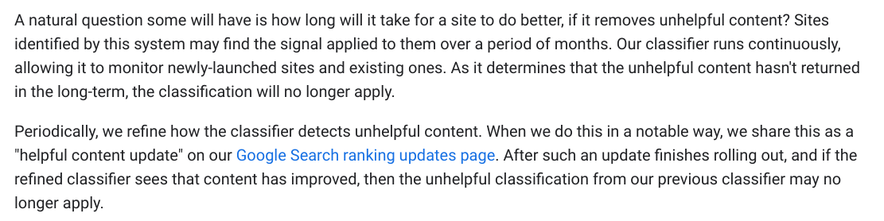

### How to reach Marie

For many years I have answered every question sent to me. Most days I answer or give my thoughts on multiple questions on social media. Unfortunately, as my audience has grown, I’m finding myself unable to help in every case.

Here’s how you can find me:

[My weekly newsletter](https://www.mariehaynes.com/seo-newsletter/)

[Twitter:](https://twitter.com/Marie_Haynes) I’ve closed my DM’s but if you have a question you are willing to tweet publicly, provided it’s something that will help others as well, I often will be able to help here.

[Youtube:](https://www.youtube.com/channel/UC5JCNbPrfBAhnVG1Cfx25qA) I have recorded a lot of content on site quality and Google’s algorithms and hope to do more soon once I get this guide out!

[Podcast](https://www.mariehaynes.com/seo-newsletter/seo-podcast/): I hope to resume this soon.

My [consulting calendar](https://calendly.com/mariehaynes) (not open anymore! I’m learning and creating content for this season now.)

I encourage you to throw out your perception of SEO rules when reviewing and improving content. So much of SEO today revolves around copying what everyone else is doing and trying to do it just a little bit better. Many of the recommendations we make as an industry are still rooted in our understanding of Google’s algorithms as they existed before AI introduced signals that can be used to indicate quality and helpfulness.

Think of your audience…and you know your audience more than anyone else…provide them with the content that they are looking for.

**Be the best option for Google to show people.**

I wish you the best of luck with your rankings!

Marie

